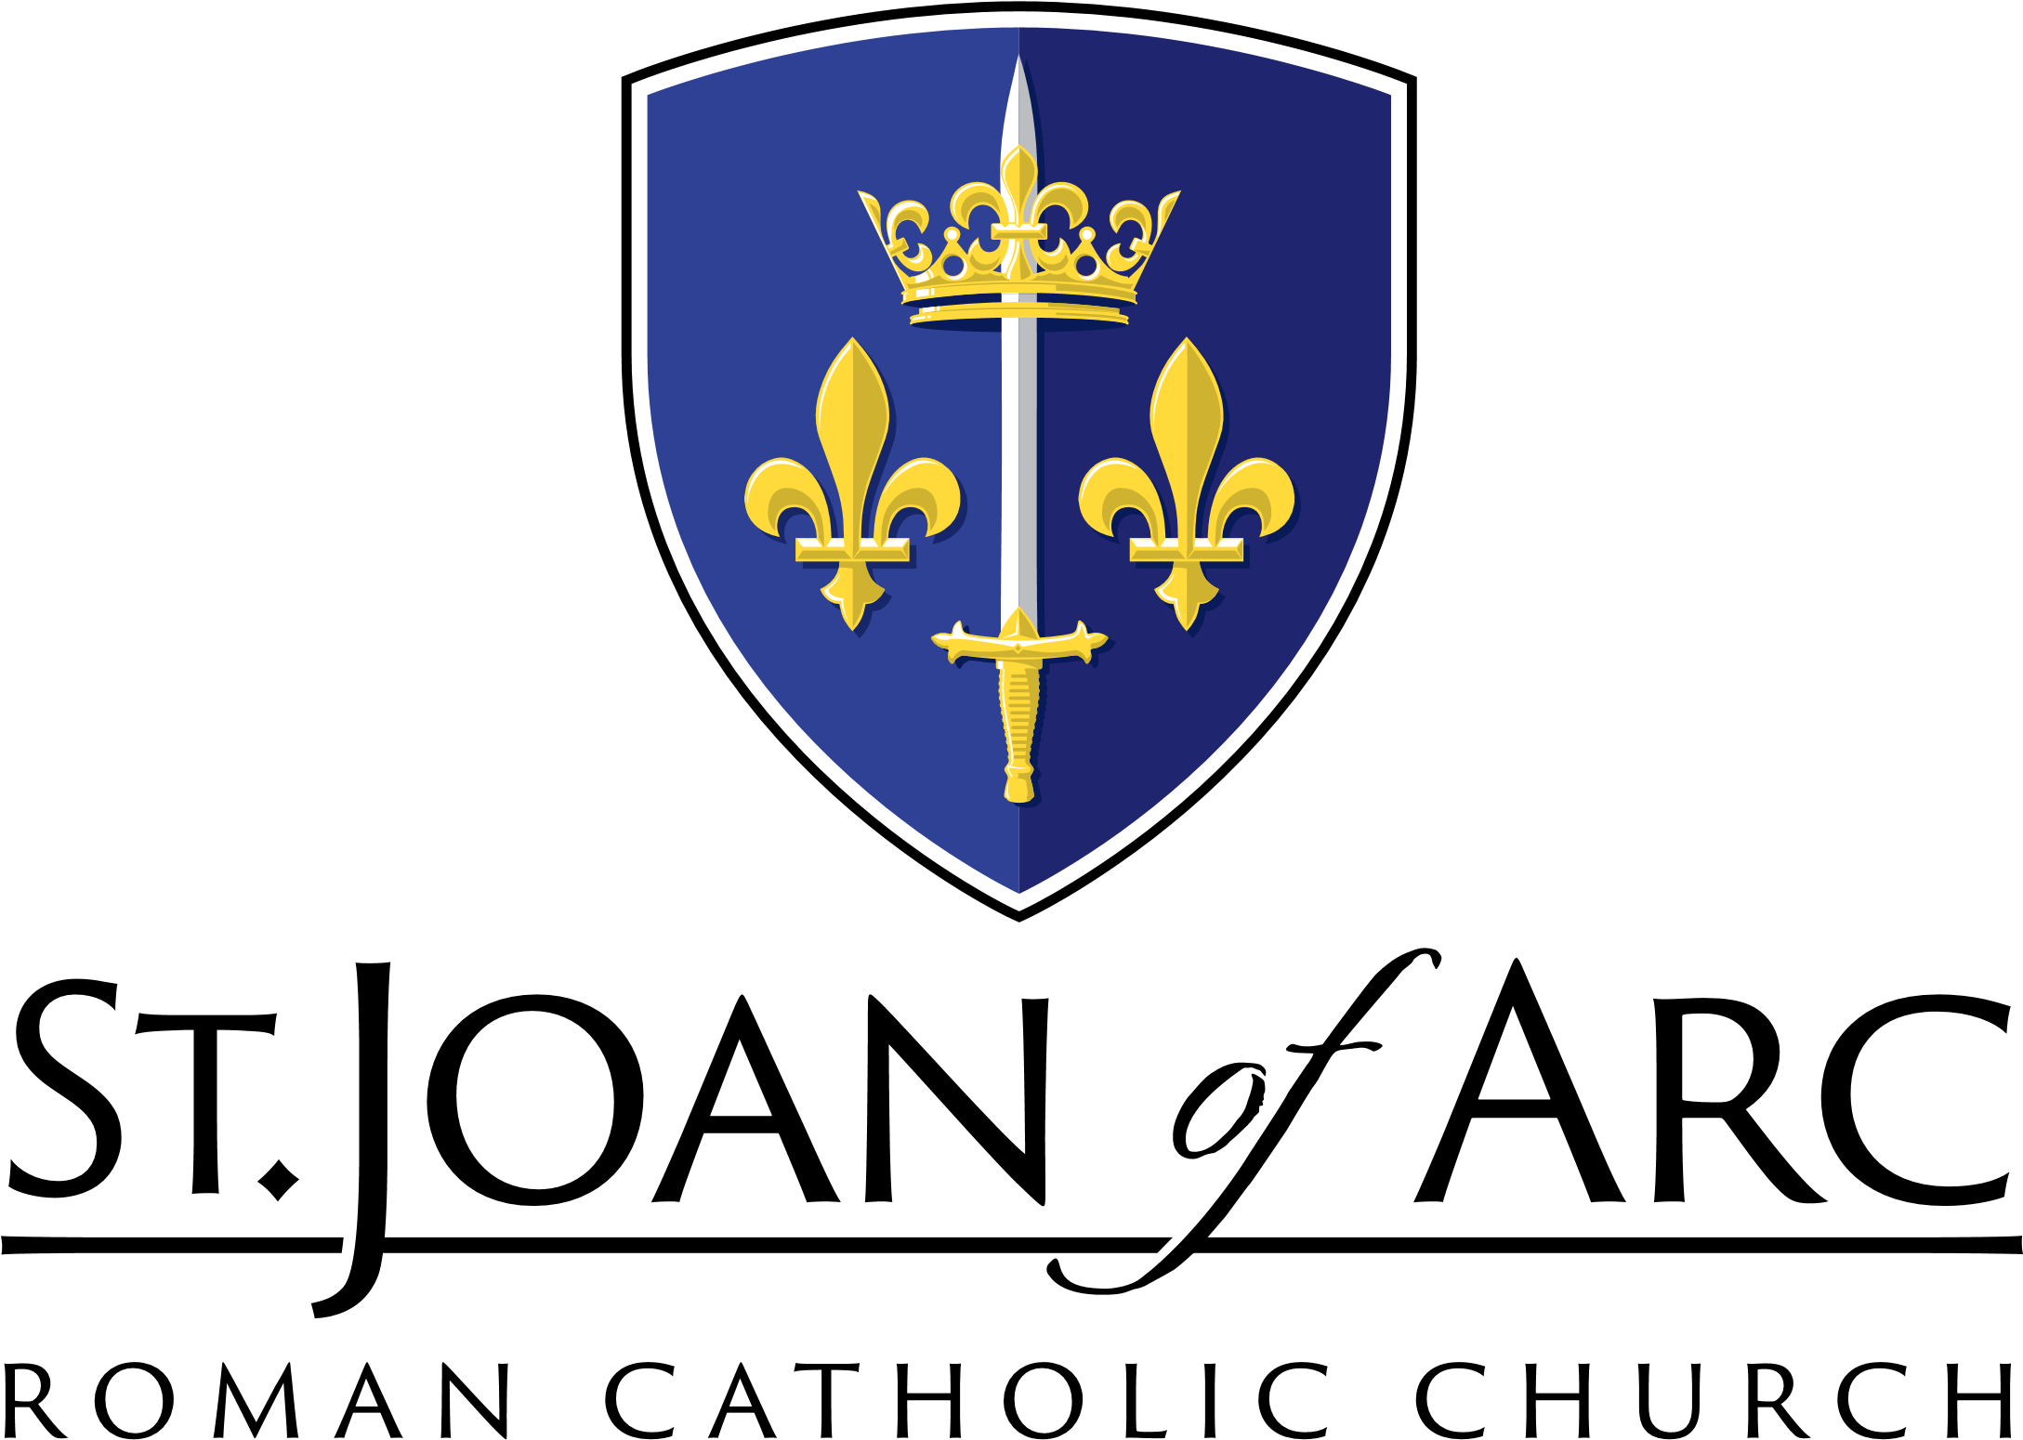
3801 E. Greenway Rd.
Phoenix, AZ 85032
Phone (602) 867-9171 | Fax (602) 482-7930

Sacramental Records Release Request

Certificates are only issued to the parent of the child, or to the person to whom the record is referring. Photo ID must be presented. There is a suggested donation of $5.

Request Date: Date of Birth:

Type of Sacrament: Baptism Marriage Confirmation First Communion Other

Name at time of Sacrament:

Approximate Date of Sacrament:

Name of your Father:

Maiden name of Mother:

Requestor:

Address:

City, State, Zip:

Daytime Telephone Number:

Email: __________________________________________________________________________________

Send to:

Address:

City, State, Zip:

Attention:

Signature:

Signature of named recipient of sacrament or authorized recipient of document.
For Office Use Only:

Photo ID verified:

Processed by:

Date Mailed:

Fee (if applicable) Paid: CA CK MO

